## **CGMM**

# **Theory Assignment – 2**

**RAY TRACING →**

In 3D computer graphics, ray tracing is a technique for modeling light transport for use in a wide variety of rendering algorithms for generating digital images.

Ray tracing is capable of simulating a variety of optical effects,such as reflection, refraction, soft shadows, scattering, depth of field, motion blur, caustics, ambient occlusion and dispersion phenomena (such as chromatic aberration). It can also be used to trace the path of sound waves in a similar fashion to light waves, making it a viable option for more immersive sound design in video games by rendering realistic reverberation and echoes.In fact, any physical wave or particle phenomenon with approximately linear motion can be simulated with ray tracing.

Ray tracing-based rendering techniques that involve sampling light over a domain generate image noise artifacts that can be addressed by tracing a very large number of rays or using denoising techniques.

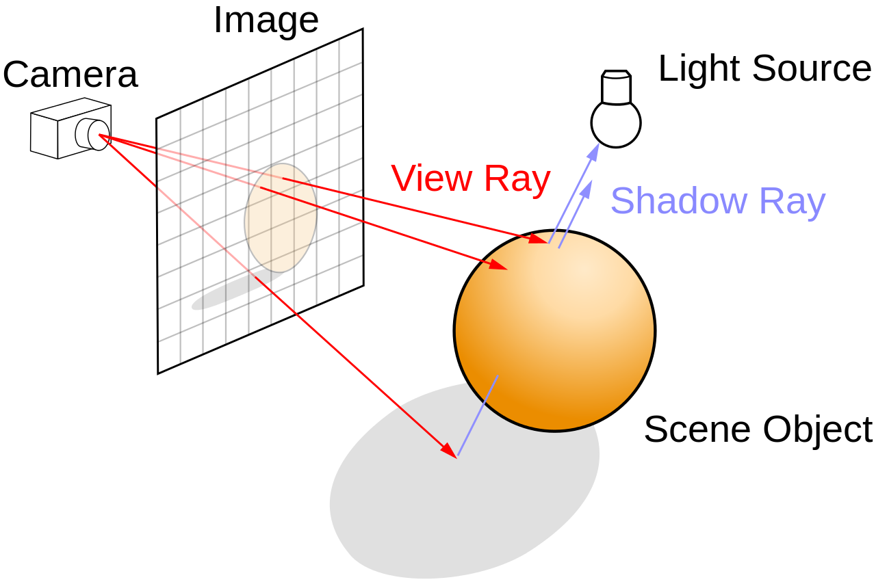

The idea of ray tracing comes from as early as the 16th century when it was described by Albrecht Dürer, who is credited for its invention.In Four Books on Measurement, he described an apparatus called a Dürer's door using a thread attached to the end of a stylus that an assistant moves along the contours of the object to draw. The thread passes through the door's frame and then through a hook on the wall. The thread forms a ray and the hook acts as the center of projection and corresponds to the camera position in ray tracing.

Optical ray tracing describes a method for producing visual images constructed in 3D computer graphics environments, with more photorealism than either ray casting or scanline rendering techniques. It works by tracing a path from an imaginary eye through each pixel in a virtual screen, and calculating the color of the object visible through it.

**Ray casting algorithm:-**

The idea behind ray casting, the predecessor to recursive ray tracing, is to trace rays from the eye, one per pixel, and find the closest object blocking the path of that ray. Think of an image as a screen-door, with each square in the screen being a pixel. This is then the object the eye sees through that pixel. Using the material properties and the effect of the lights in the scene, this algorithm can determine the shading of this object. The shading of the surface is computed using traditional 3D computer graphics shading models. One important advantage ray casting offered over older scanline algorithms was its ability to easily deal with non-planar surfaces and solids, such as cones and spheres.

**Recursive ray tracing algorithm:-**

* A reflection ray is traced in the mirror-reflection direction. The closest object it intersects is what will be seen in the reflection.
* A refraction ray traveling through transparent material works similarly, with the addition that a refractive ray could be entering or exiting a material. [Turner Whitted](https://en.wikipedia.org/wiki/Turner_Whitted) extended the mathematical logic for rays passing through a transparent solid to include the effects of refraction.
* A shadow ray is traced toward each light. If any opaque object is found between the surface and the light, the surface is in shadow and the light does not illuminate it.

**Advantages over other rendering methods:-**

Ray tracing-based rendering's popularity stems from its basis in a realistic simulation of light transport, as compared to other rendering methods, such as rasterization, which focuses more on the realistic simulation of geometry. Effects such as reflections and shadows, which are difficult to simulate using other algorithms, are a natural result of the ray tracing algorithm. The computational independence of each ray makes ray tracing amenable to a basic level of parallelization,[20][21] but the divergence of ray paths makes high utilization under parallelism quite difficult to achieve in practice.

**Disadvantages:-**

A serious disadvantage of ray tracing is performance (though it can in theory be faster than traditional scanline rendering depending on scene complexity vs. number of pixels on-screen). Scanline algorithms and other algorithms use data coherence to share computations between pixels, while ray tracing normally starts the process anew, treating each eye ray separately.

Although it does handle interreflection and optical effects such as refraction accurately, traditional ray tracing is also not necessarily photorealistic. True photorealism occurs when the rendering equation is closely approximated or fully implemented.